# Compass MED D - Test Claim - Addressing Medications Available in Multiple Forms

Addressing Medications Available in Multiple Forms

Related Documents

**Description:** This document provides general reminder for addressing medications available in multiple forms.

|  |
| --- |
| Addressing Medications Available in Multiple Forms |

Some medications come in different forms such as tablets, granules, liquids, etc.

It is important to ask the caller to specify which version of medication they are taking. The name can be located on the prescription bottle.

**Example:** Metoprolol is one medication that comes in multiple forms (Metoprolol SUC, Metoprolol Tar, and Metoprolol ER).

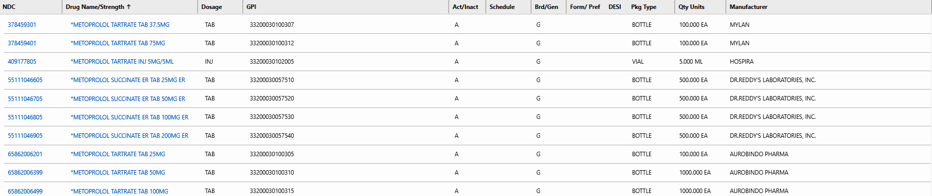

If the caller questions the difference in the medication, please reach out to [Clinical Care Services](CMS-2-004378) for assistance.

**Note:** If the claim denies, review the rejection code to determine what caused the denial. Once the rejection code is identified, access the proper work instruction and job aids in theSource to help you resolve the issue.

Top of the Document

|  |
| --- |
| Related Documents |

[Compass MED D - Test Claim Index](TSRC-PROD-061874)

**Abbreviations / Definitions:** [Customer Care Abbreviations, Definitions, and Terms](CMS-2-017428)

Top of the Document

Not To Be Reproduced Or Disclosed to Others Without Prior Written Approval

**ELECTRONIC DATA = OFFICIAL VERSION / PAPER COPY – INFORMATIONAL ONLY**